**Project Report Template**

1. **INTRODUCTION**

* 1. Overview

Retailing encompasses the business activities involved in selling goods and services to consumers for their personal, family, or household etc. A CRM product owner has requested to create two applications, one is a sales app for sales reps to use this application and store customers data, and the second application is a service app for service reps\agents to provide support to customers in dealing cases. To generate business on top of the customers.

* 1. Purpose

Retail management refers to the process that strives to make sure that consumers are satisfied with the products and services they buy and that retail establishments function well and continue to be profitable.

1. **Problem Definition & Design Thinking**

2.1 Empathy Map

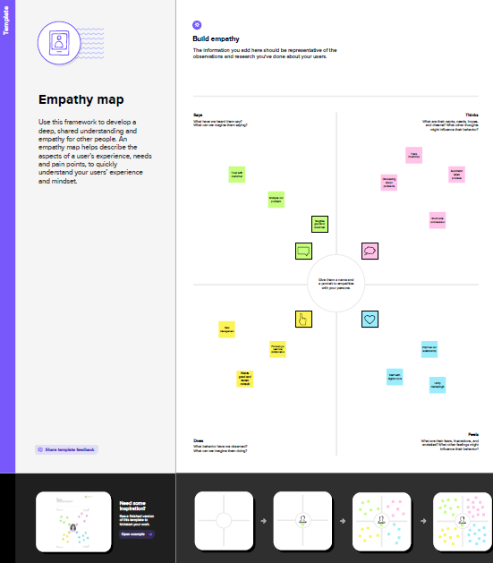

2.2 Ideation & Brainstorming Map

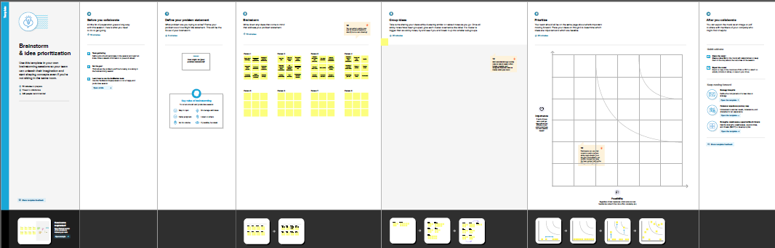

1. **RESULT**

3.1 Data Model:

|  |  |
| --- | --- |
| **Object name** | **Fields in the Object** |
| Dispatch/Tracking | |  |  | | --- | --- | | Field label | Data type | | Diplay/tracking | Text | | Dispatched | Checkbox | |
| Relationship between objects | |  |  | | --- | --- | | **Field label** | **Data type** | | Sales order | Master detail relationship | |
| Account | |  |  | | --- | --- | | **Field label** | **Data type** | | Account | Text | |
| Contact | |  |  | | --- | --- | | **Field label** | **Data type** | | Account website | Formula | |

3.2 Activity & Screenshot

Salesforce is your customer success platform, designed to help you sell, service, market, analyze, and connect with your customers.

Creation of object dispatch/Tracking:

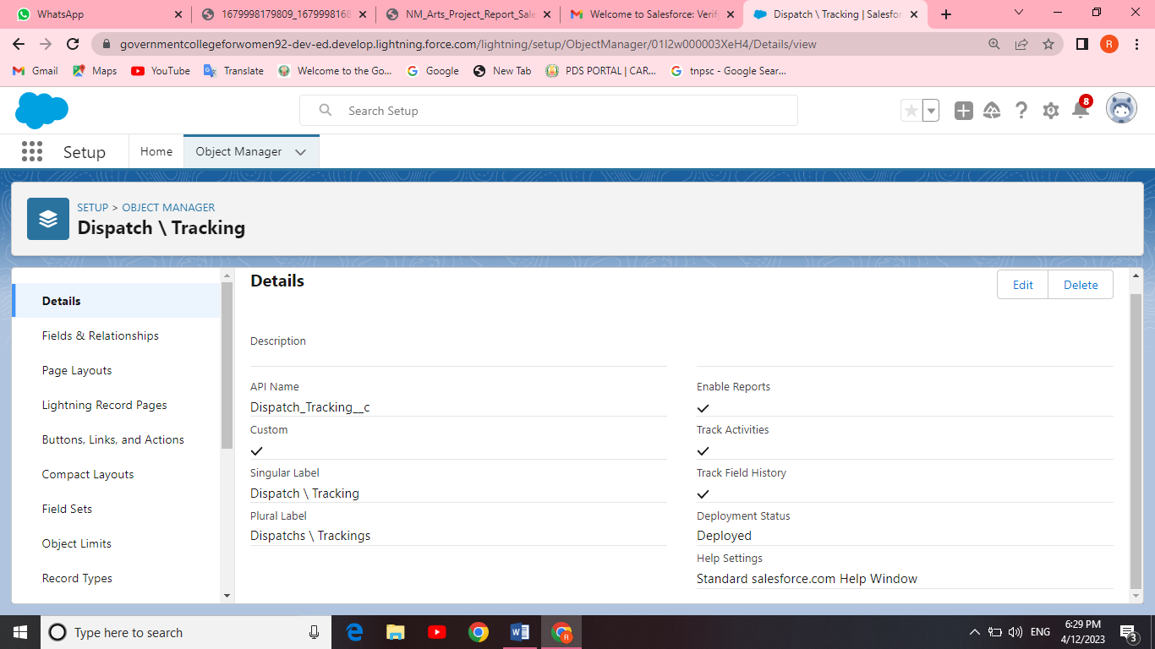

Salesforce can be used to manage orders from retail stores and distributors, including tracking orders, processing payments, and managing inventory levels.

Fields available on Dispatch/Tracking

This can help field sales teams ensure that orders are fulfilled quickly and accurately and that inventory levels are maintained at optimal levels.

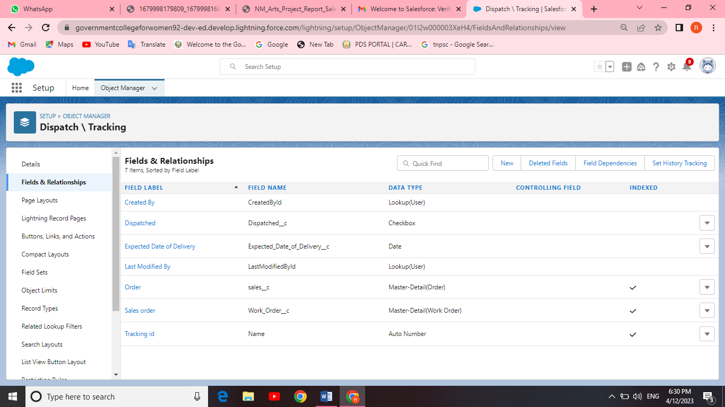

Creation on relationship between objects:

It's time to take things to the next level with object relationships. Object relationships are special field types that connect two objects. As a CRM product owner create relationships to link objects with each other, so that when users view records, they can also see related data.

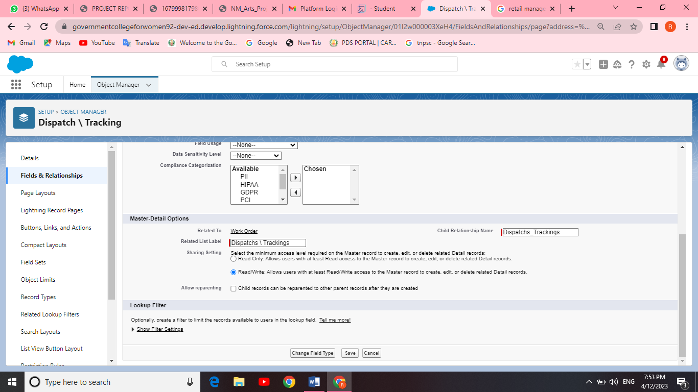

Creation of Application:

Apps in Salesforce are a group of tabs that help the application function by working together as a unit. It has a name, a logo, and a particular. An app is a collection of items that work together to serve a particular function. Salesforce apps come in two flavors: Classic and Lightning.

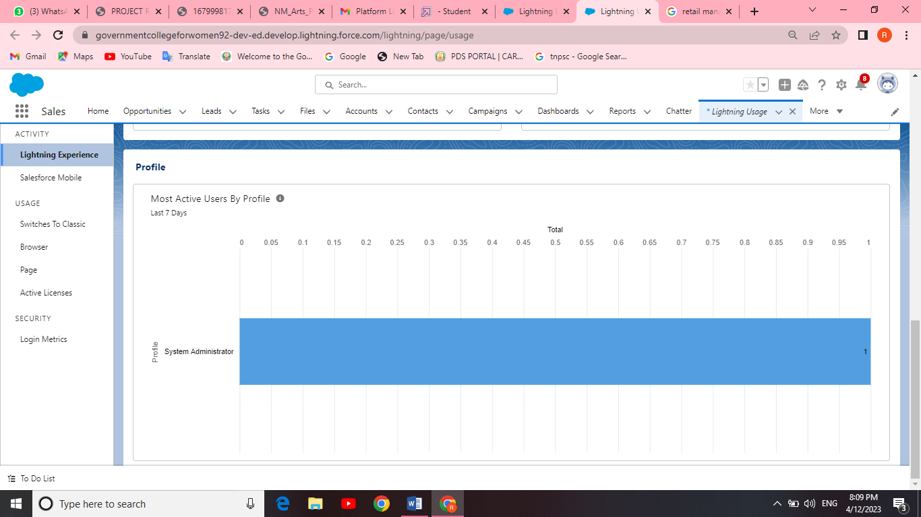

Creation of custom Tabs:

Page layouts control the layout of an object, As a crm product owner create custom page layouts which defines which fields the user can view and edit while entering data in objects. And must contain different sets of fields and related lists,

Custom Page layouts:

1) Warehouse page layout.

2) Sales order layout.

3) Dispatch/Tracking layout.

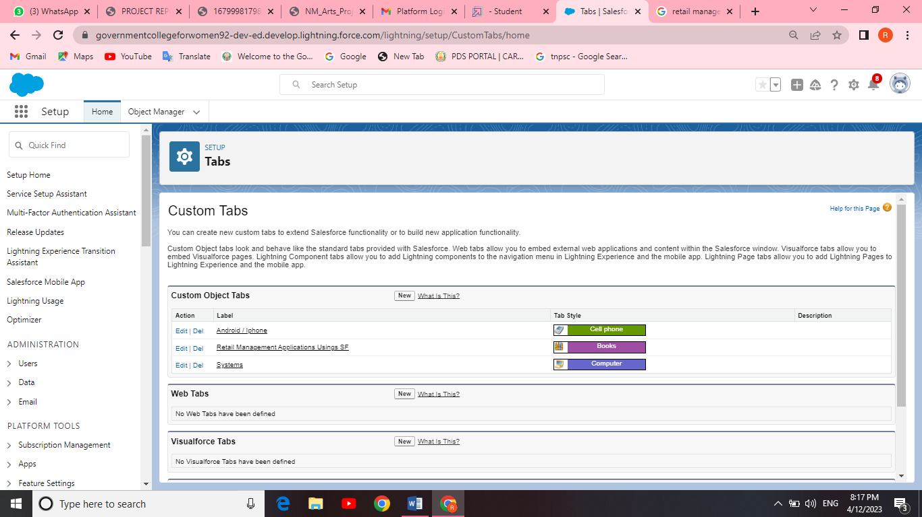

Creation of user:

 A user is anyone who logs in to Salesforce. Users are employees at your company, such as sales reps, managers, and IT specialists, who need access to the company's records. Every user in Salesforce has a user account.



Creation of validation rule:

Validation rules verify that the data a user enters in a record meets the standards you specify before the user can save the record. As a CRM product owner they requested to create a validation rule on account object on the phone field.

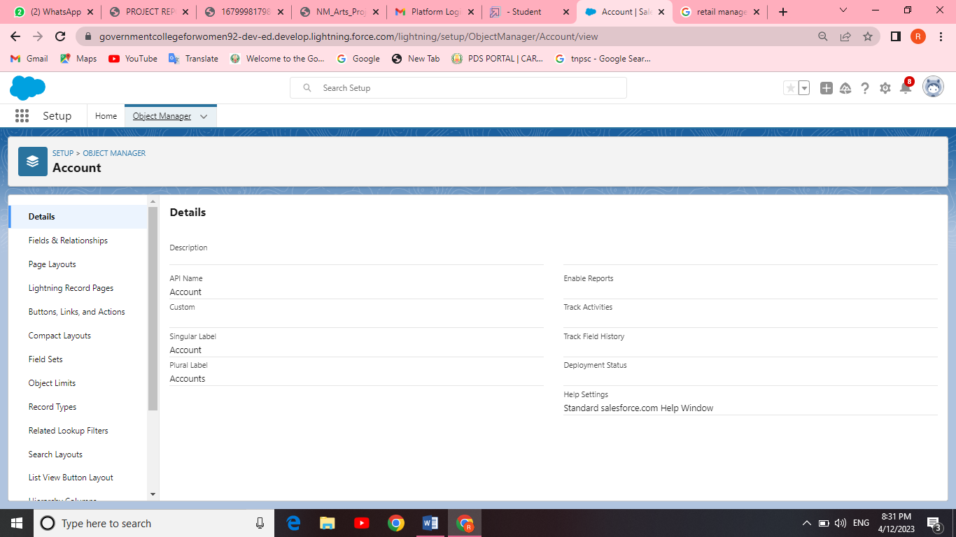

Creation of cross object :

Using an object formula lets you reference merge fields on a master object from a master detail relationship on the detail object. As a CRM product owner they wants to save user’s clicks and displays contacts' parent accounts website value on the contact record so users do not have to click on the account to find the website.

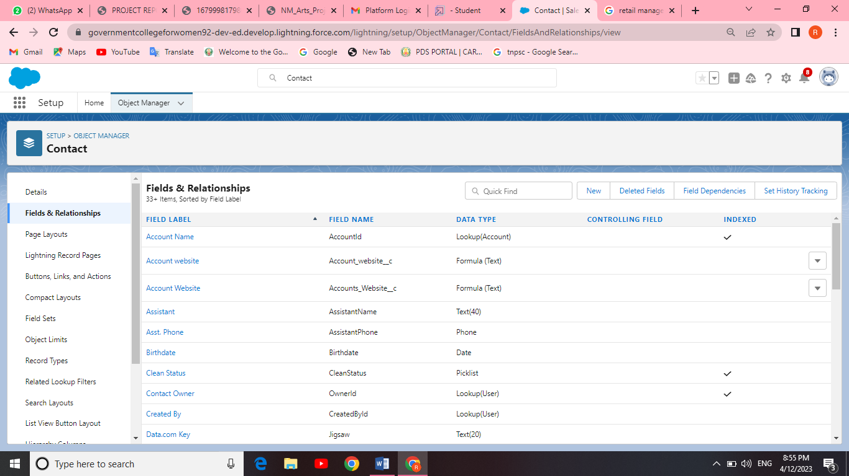

Creation of Report:

A report is a list of records that meet the criteria you define. It's displayed in Salesforce in rows and columns, and can be filtered, grouped, or displayed in a graphical chart. Every report is stored in a folder.

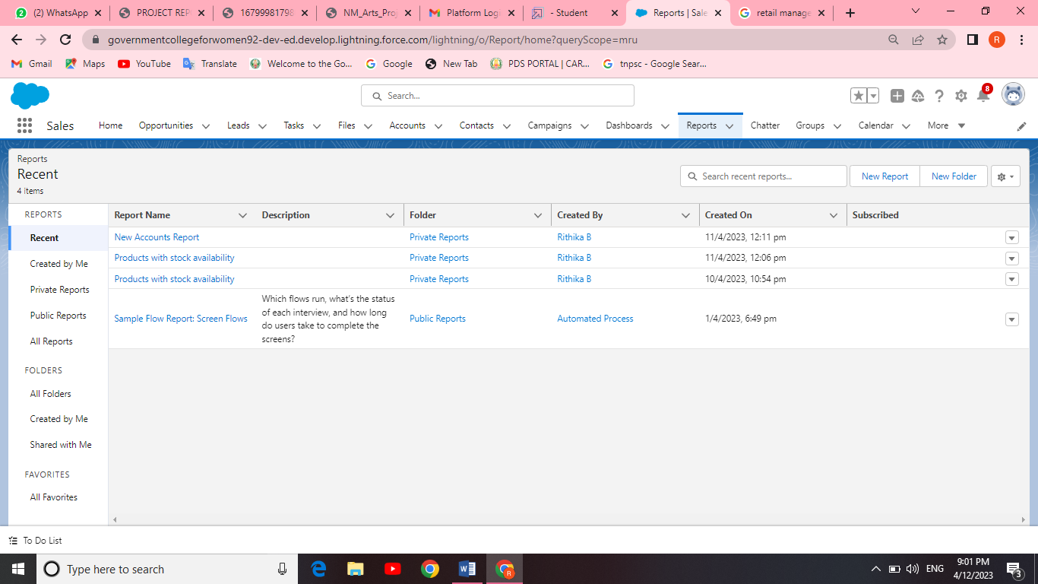

Creation of Dashboard :

Dashboards in Salesforce are a graphical representation of Reports. It shows data from source reports as visual components.

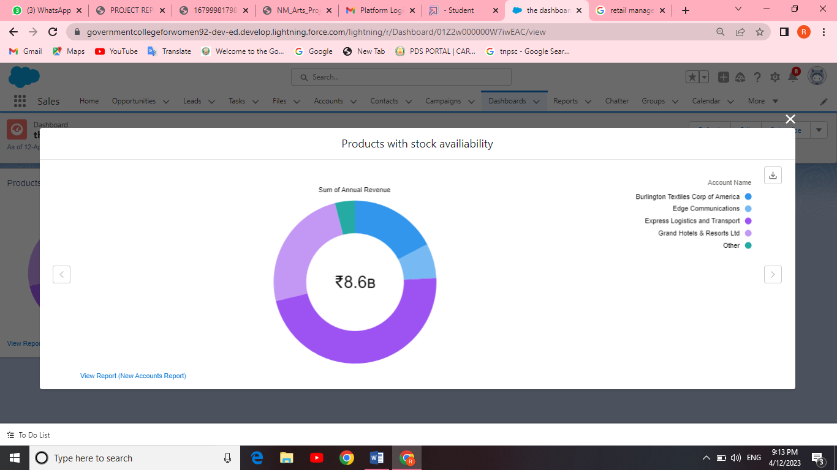

1. Trailhead Profile Public URL

Team Leader : <https://trailblazer.me/id/rbaskar16>

Team Member 1 : <https://trailblazer.me/id/ppraba23>

Team Member 2 : <https://trailblazer.me/id/vvaishuvaithi>

Team Member 3 : <https://trailblazer.me/id/rathr8>

1. ADVANTAGES AND DISADVANTAGES

Advantages:

* Automated Sales Processes: With Salesforce, you can automate your sales processes and make them more efficient. .
* Improved Customer Relationships: With Salesforce, you can keep track of your customers' movements and interactions in a centralized location
* The retailer must keep a record of all the products coming into the store.
* The products must be well arranged on the assigned shelves according to size, colour, gender, patterns etc.
* Connect With Your Customers.
* Know How Your Business is Doing .

Disadvantages:

* Expensive.
* You have to pay for add-ons to get the most out of the software.
* Configuration and setup is complex and time-consuming.
* Cluttered interface makes navigation and simple tasks unnecessarily complex.
* The learning curve never seems to end.
* Customer support has a poor reputation.

1. APPLICATION

* Information systems are the tools, hardware and software that help retailers achieve success in a dynamic environment.
* They serve several functions including **planning, inventory control, managing budgets and sales goals, and also with point of sale transactions and logistics**.
* Its been developed for each of those areas. Example applications include finances, marketing, manufacturing and human resources. Each type of MIS is designed to meet the needs of management in those departments or units.

1. CONCLUSION

* Retail management refers to **the process of helping customers find products in your store**.
* It includes everything from increasing your customer pool to how products are presented, and how you fulfill a customer's needs. A good store manager helps customers leave the store with a smile.
* We **help your marketing, sales, commerce, service and IT teams work as one from anywhere** , so you can keep your customers happy everywhere.

1. Future scope

As the demand for any Salesforce job role is high, a certification equips you with specialized Salesforce requirements. The right Salesforce training props you ahead in a niche area where **the scope for career growth and salary is sky-high.**